Balancing sensing linearity and energy harvesting in ceramic microbial fuel cells: the anode architecture and electrical loading trade-off

Introduction
Context & issue: Threat of sudden organic pollution spikes (e.g., agricultural runoff, sludge discharge) in oligotrophic surface waters (our low background COD <20 representing this). Importance of early detection. Conventional monitoring methods – chemical lab-based COD testing takes time, labour, reagent waste. Automatic monitoring using sensors is emerging for this. However, optical or chemical sensors require grid power and frequent maintenance.
Microbial Fuel Cell (MFC) sensors have potential to offer self-powered, low-maintenance monitoring. MFC as dual-function platforms: current as proxy for COD, ceramic membrane MFCs are robustness, low cost, scalability for field deployment. A technology that uniquely couples biosensing with usable electrical power generation making them suitable for the development of new self-powered/energy-autonomous sensors for example soft-sensors that combine MFC electrical output with low-power embedded machine learning (ML) to enhance sensing performance.
Knowledge gap: previous studies on MFC based environmental biosensors typically focus on sensing capability in terms of sensitivity, response time, and detection range in isolation. The use of feature engineering from MFC electrical output combined with machine learning to enhance the response time and accuracy of MFC sensing has been underexplored. Power output and sensing performance rarely optimised jointly, and this combined optimisation Is needed for self-powered device design. While AC enhances capacitance for energy storage, it introduces transient charge accumulation that can decouple current output from real-time substrate concentration changes [REF]. To what extent do MFC anode modification (using AC), electrode size (100 cm2 vs 600 cm2), and external load (Rext relative to Rint?) affect power output, and accuracy (R²) and response time of COD sensing? Is there a trade-off between power production and sensing performance when selecting these design parameters? These questions are investigated using ceramic-membrane MFC architectures and lightweight ML models suitable for deployment on low-power microcontoller?
Hypothesis & aims: (Quantifying the trade-off between power harvesting and sensing fidelity) AC-modified and large-area anodes favour power generation over transient sensing linearity due to mass-transfer limitations and capacitive buffering effects. We systematically quantify this sensing-energy trade-off across 4 anode types and 3 loading regimes under realistic low COD river conditions. Significance/novelty?

Materials and methods

MFC fabrication and anode modifications
Figure 1. Schematic of ceramic MFC biosensor and 4 anode types.

Experimental setup and transient COD spike tests
Inoculum, start-up, maturation, background river water

Electrical load selection

Water analysis and data recording
Data collection frequency (30s). Metrics: peak voltage (Vpeak), hourly transient voltages (V1h, V2h, V3h), linearity metrics (R2), response latency? (Tpeak)

2.5

Results and discussion

Dynamic response to organic loading shocks
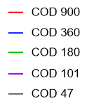
Figure 2. Voltage response profiles of COD spike tests under R_{EXT} of 1KΩ. Each line represents mean values of biosensor triplicates.
The characteristic shape of the response (baseline $→$ sudden spike $→$ gradual voltage rise $→$ peak formation)

Impact of anode architecture on sensing linearity and signal retention
Sensing performance across anode types
Voltage response to COD spikes: sensitivity, linearity (R²), response/recovery time, detection range
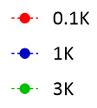
Figure 3. Vpeak vs. COD concentration regression plots for all 4 anode types (! 600 AC failure).
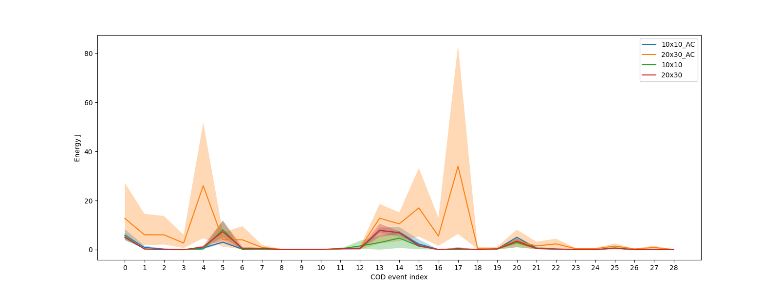
Figure 4: Placeholder Figure – replace with Energy vs. COD concentration, average and variance for each MFC type, under R_{EXT} of 1KΩ

Compare peak values (Figure 3), response profiles (Figure 2), time-to-peak (generate plot – this is very inconsistent across all MFCs), energy generation (Figure 4)
Activated-carbon modification and larger electrode size appear beneficial for power generation due to greater peak power output, sustained oner longer duration for a given COD value.
Plain electrodes, smaller size show potential for more accurate sensing due to greater linearity (R2) between COD concentration Vpeak.

Plain anodes: Strong linear correlation between peak voltage and COD concentration (R2 = 0.81-0.86)
Small AC anode (100 AC): Achieves the highest overall peak linearity (R2 = 0.91)
Large AC anode (600 AC): Fails as a linear linear-peak sensor (R2 = 0.093) double-layer capacitance of large-scale activated carbon stores charge, decoupling immediate substrate degradation from transient voltage response. high surface area combined with activated carbon creates massive electric double-layer capacitance. The anode acts as a supercapacitor, storing generated charge rather than immediately passing it through the circuit during transient COD spikes. This smooths out the peak and destroys linear concentration tracking.
response time is governed by times for biological, diffusion and capacitive reactions

Impact of external load (Rext) on sensing and power harvesting
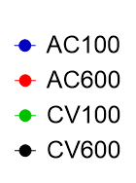
Figure 4. Polarisation and power curves of tested anode types under background water with different COD values: (A) river water only; (B) COD of 180 mg/L; (C) COD of 856 mg/L
Operating near internal resistance generally yields the best linearity across most anodes? (R2 > 0.84-0.90) compared to over-loaded or under-loaded conditions? But internal resistance changes in response to the COD of feedstock.
Heatmap: combined heatmap matrix (4 anodes x 3 loads). Colour-code cells by R2 value on one half and power output on the other to visually prove the trade-off?
Table. R²
 | External load (R_{EXT})
R² | 0.1K | 1K | 3K
AC100 | 0.7334 | 0.9098 | 0.8228
AC600 | 0.0137 | 0.0928 | 0.3614
CV100 | 0.5563 | 0.8472 | 0.4827
CV600 | 0.6689 | 0.8779 | 0.7149

Interplay of anode architecture and load
(Mapping the sensing-power trade-off)
Activated-carbon modified anodes were originally incorporated because of their anticipated advantages for power production and potential self-powered sensing applications. Optimising an MFC for power generation may not optimise it for sensing.

Heat map? R² vs. power density across all anode × load combinations?
Table X. Summary metrics: anode type, Rext, Peak R2, 1h R2, Avg Tpeak, power output
Time-to-Peak Latency: substantial lag (hours to reach Vpeak) across all setups due to low substrate flow rates and ceramic mass transfer constraints. Time-to-peak latency is also highly inconsistent across all MFCs, even under the same conditions. Identification o fa peak is also, by nature, only possible after the peak has occurred. All of this makes it very difficult to use Vpeak in practice for COD sensing. A natural next step is to evaluate the accuracy (R2) of COD sensing, a fixed time from the COD spike, rather than at the peak.

Evaluation of alternative sensing indices
(early window vs. peak features)
Practical deployment limitations
Peak voltage provided the strongest COD correlation compared to voltages recorded at proceeding timesteps, but substantial sensing information was already present before peak development.
For CV anodes, and small AC anodes, strong linearity is achieved at V1h (R2 > 0.75 ) (Figure 5), and E3h (R2 > 0.9)_(Figure 6) demonstrating that actionable water quality alerts can be extracted hours before reaching electrochemical equilibrium.

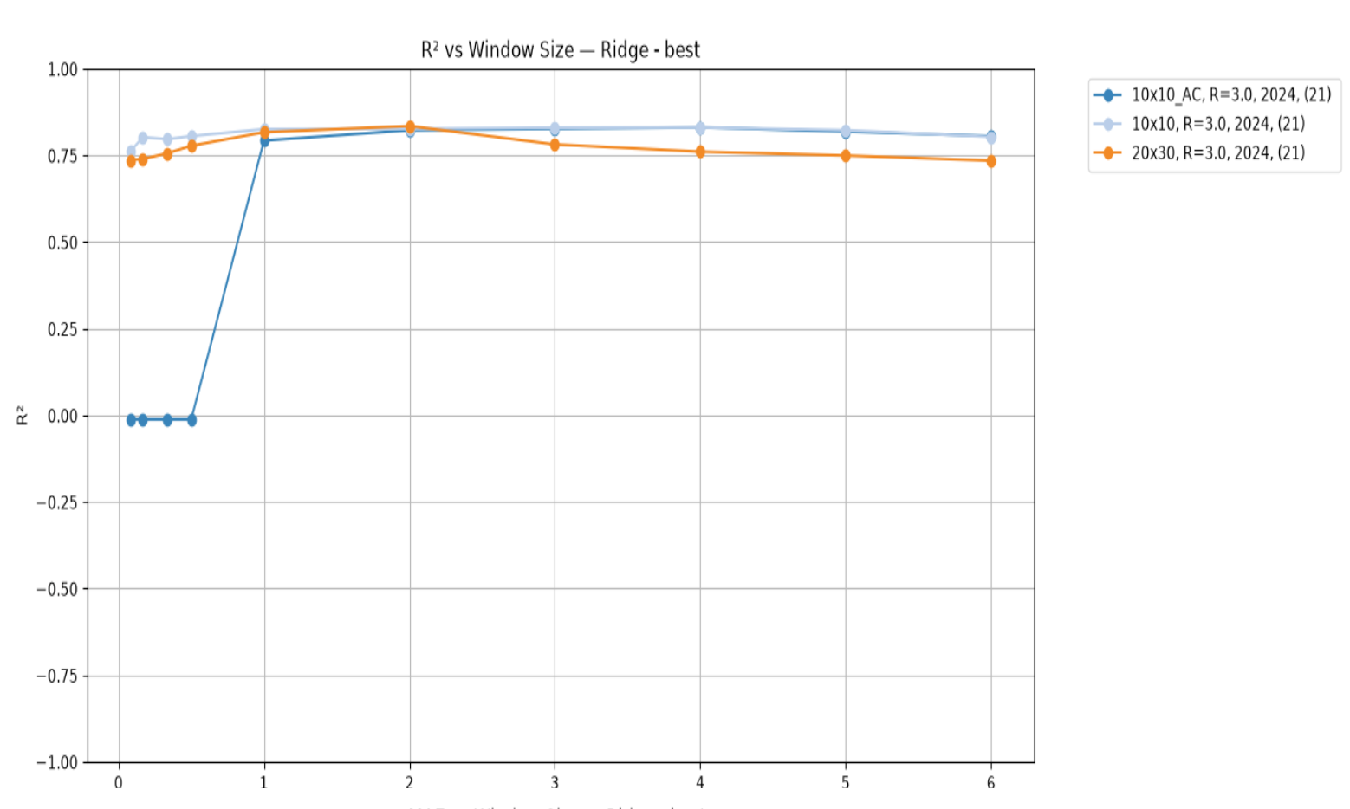
Figure 5: Evolution of linearity of COD sensing using the MFC voltage at fixed timesteps (hours) since COD event. MFC configurations shown produced the greatest R2 value of all MFC configs at at least one of the timesteps evaluated.
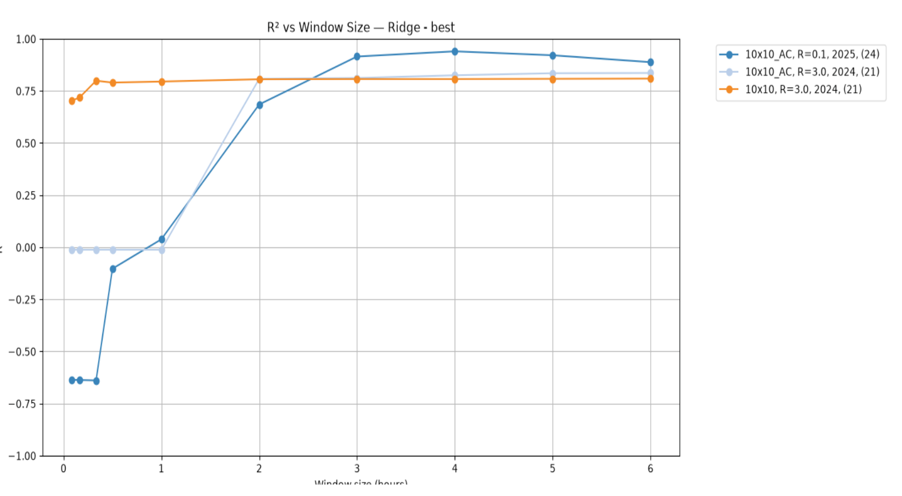

Figure 6: Evolution of linearity of COD sensing using the MFC cumulative energy produced at fixed timesteps (hours) since COD event. MFC configurations shown produced the greatest R2 value of all MFC configs at at least one of the timesteps evaluated.

If multi-parameter (Vpeak, Ppeak, Energy, Resistance, Vfinal, Pfinal) linear regression is instead performed using a ridge regression algorithm, then R2 > 0.9 can be achieved in < 1h, and as early as 10 mins from a COD event (Figure 7)
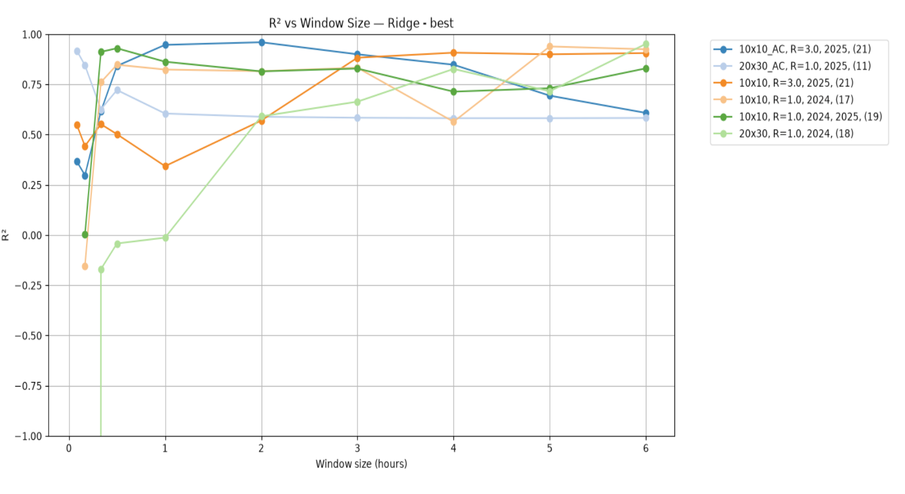
Figure 7: Evolution of linearity of COD sensing using a ridge regression algorithm (with features Vpeak, Ppeak, Energy, Resistance, Vfinal, Pfinal) at fixed timesteps (hours) since COD event. MFC configurations shown produced the greatest R2 value of all MFC configs at at least one of the timesteps evaluated.

Figure X. Correlation Matrix / R2 Progression (1h, 2h, 3h, Peak) across anode types. the correlation (R2) evolves over time?

Design implications and system architecture guidelines
Practical guidelines for deployable, dual-mode, self-powered sensing networks
Dual-anode array architecture: a multi-cell module combining a small plain anode (e.g., CV100 for rapid, linear early-transient sensing) with a large capacitive anode (e.g., AC600 for continuous power generation to support the energy needs of integrated machine learning or wireless telemetry).
Load management: dynamic electrical load switching (e.g., operating at Rext ~ Rint during normal operation, switching to low Rext to rapidly discharge capacitive anodes after a pollution event).

Conclusions
Summary of key findings: 100 AC delivers optimal Vpeak accuracy (R2 = 0.91), while plain and small anodes offer superior early-window predictability (R2>0.75 at 1h). This increases to R2 > 0.9 at < 1h if multi-parameter linear regression is fitted using a ridge regression algorithm.
Large AC anodes (600 AC) are unsuitable for direct transient COD sensing due to capacitive retention (R2 < 0.10) but are suited for baseline energy harvesting due to superior sustained power production.
Practical recommendations for deployable ceramic MFC biosensor design: dual-mode, self-powered environmental biosensing networks.
Future research directions: adaptive/switchable load control, field trials, long-term stability. The results are obtained using tiny data sets allowing investigation of a large number of different MFC configurations (external load, electrode size, electrode material). However, further work should investigate larger data sets by focusing on specific MFC configurations identified as better suited to sensing. Larger datasets can typically result in greater prediction accuracy, which may improve the viability of early-window predictions advancing progress towards self-powered, field deployable sensors for pollution spikes.

